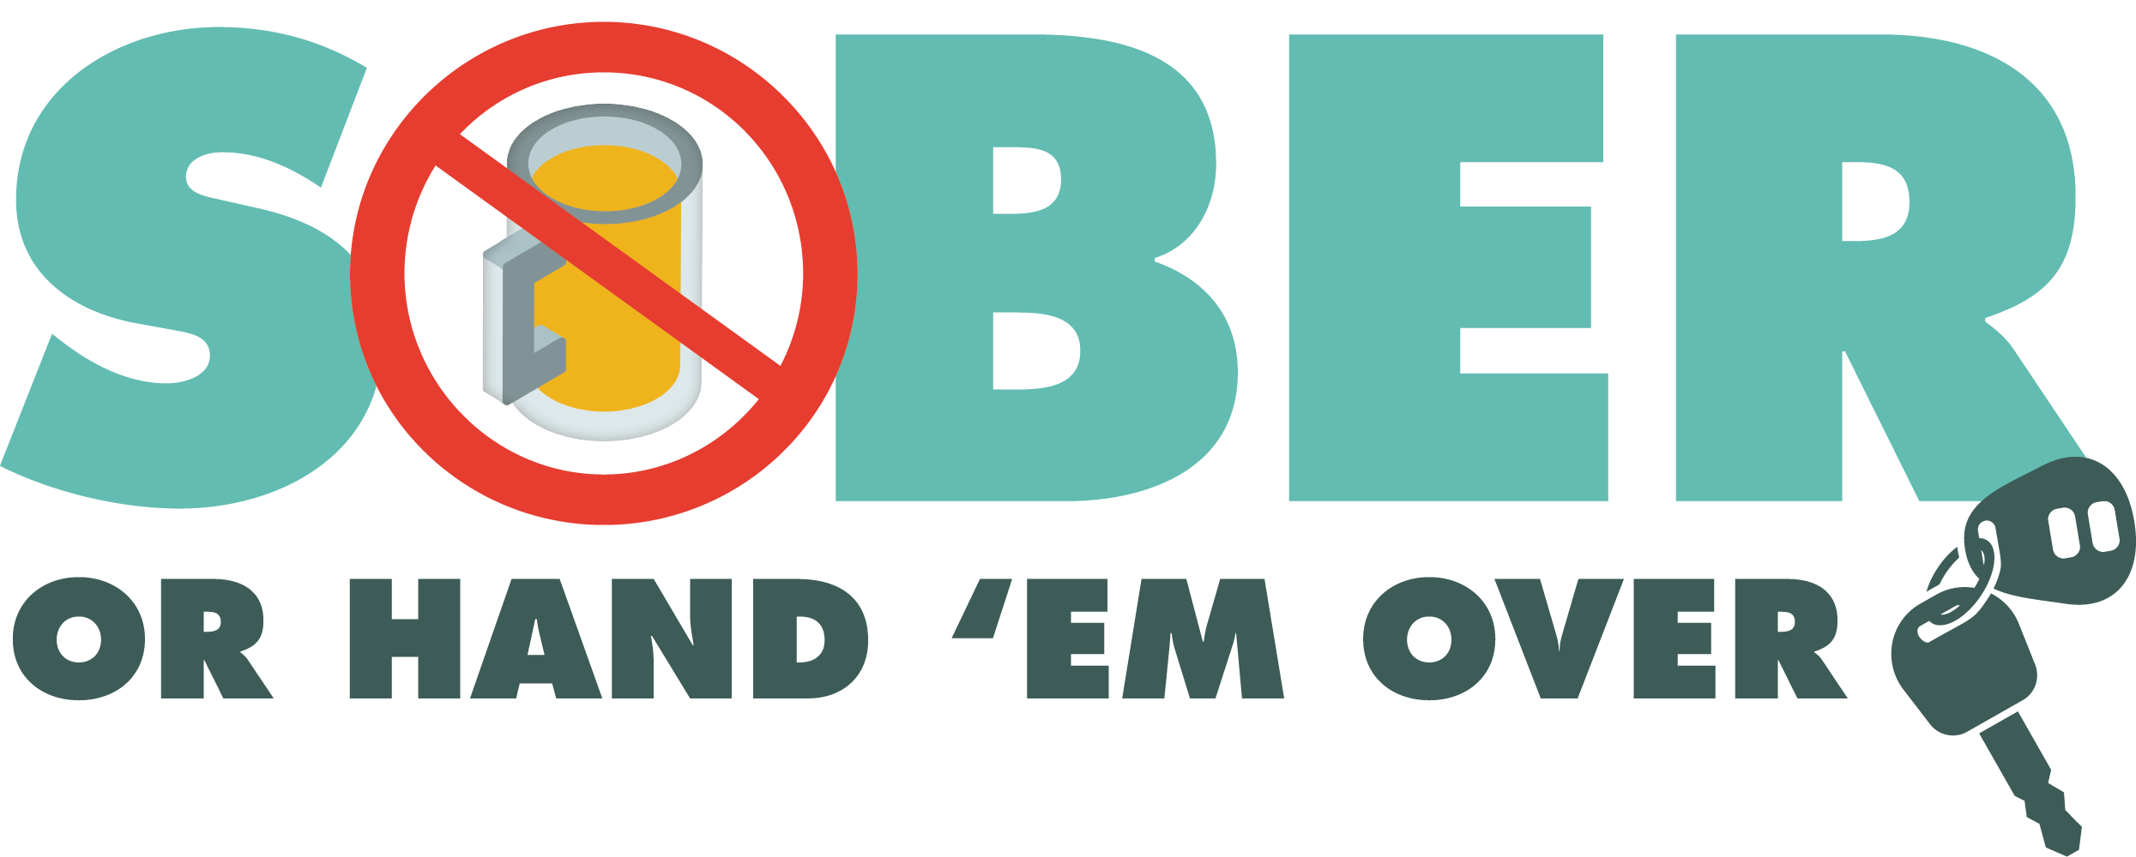



**FOR IMMEDIATE RELEASE**

**Date: September 2, 2025**

**Lt. C. Limon**

**Guadalupe Police Department**

**climon@ci.guadalupe.ca.us**

**Office Phone: (805) 343-2112**

**Guadalupe Police Department Holding DUI Checkpoint September 05, 2025**

Guadalupe, Calif. – On September 05, 2025, the Guadalupe Police Department will conduct a driving under the influence (DUI) Checkpoint September 05, 2025, from 1900 pm to 0000 am at an undisclosed location.

DUI checkpoint locations are determined based on data showing incidents of impaired driving-related crashes. The primary purpose of DUI checkpoints is to promote public safety by taking suspected impaired drivers off the road.

“Impaired drivers put others on the road at significant risk,” Lt. Limon said. “Any prevention measures that reduce the number of impaired drivers on our roads significantly improve traffic safety.”

The Guadalupe Police Department reminds the public that impaired driving is not just from alcohol. Some prescription medications and over-the-counter drugs may interfere with driving. While medicinal and recreational marijuana are legal, driving under the influence of marijuana is illegal.

Drivers charged with a first-time DUI face an average of $13,500 in fines and penalties, as well as a suspended license.

Funding for this program was provided by a grant from the California Office of Traffic Safety, through the National Highway Traffic Safety Administration.

**# # #**